. **Pushkar Nath Handoo**

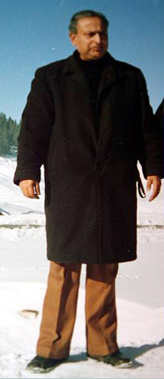

**About:**